Grant Activity Summary
Boulder City historically has received several grants each year. In general terms, these grants are commonly referred to as formula grants – meaning that the various federal programs automatically set-aside funding for grants to participating entities using a formula to determine the annual amount. One caveat – while the grants are automatically calculated by the federal agencies, the participating entities still need to take actions to apply and then receive the grants. Finance Department Staff will continue to offer support to the various city departments who receive formula grants.

The City also receives grants from State agencies, and from local trade associations and businesses. These grants vary from year to year, dependent on the granting agency/association/business on their available funds. As with the Federal Grants, the City is required to take actions to receive these grant awards. As deemed appropriate for each continuing grant application, Finance Department Staff will assist the various departments or take over the grant application process.

For calendar year 2017 through the present (as of March 20, 2019), Boulder City received the following grants (listed in chronological order as awarded):

Note: The grant totals do NOT include the grants the City receives from the Regional Transportation Commission for Southern Nevada (“RTC”) or the Regional Flood Control District for Clark County (“RFC”).

2017 Grants
Granting Agency | Amount | Purpose
Clark County Community Services (CDBG grant – city has interlocal agreement with the County to receive annually a percentage of the County’s CDBG entitlement award) | $206,857 | Lakeview Addition roadway rehabilitation, new retaining wall on Elm Street Alley, social service grants to Lend-A-Hand and Emergency Aid
Southern Nevada International Code Council | $2,000 | Swimming lessons for toddlers
Nevada Department of Transportation – Aviation Division | $9,721 | From Aviation Trust Fund, grant to help our airport off-set the required local match for federal aviation grants
Federal Aviation Administration | $2,294,581 | Annual FAA grant for capital projects – partially a competitive grant – formula provides for $1.5M annually, any amount above the $1.5M is based on Airport Improvement Program eligibility, inclusion in the airport Master Plan, demonstrated need and readiness of projects
Nevada Department of Public Safety | $35,500 | Joining Forces Grant
Nevada Department of Conservation and Natural Resources | $45,000 | OHV Grant Program to purchase an OHV vehicle for the police department and pay for admin costs related to approved expenses.
TOTAL GRANT AMOUNTS FOR 2017 | $2,593,659
2018 Grants
Clark County Community Services (CDBG grant – city has interlocal agreement with the County to receive annually a percentage of the County’s CDBG entitlement award) | $229,920 | Roadway rehabilitation, social service grants to Lend-A-Hand and Emergency Aid
Southern Nevada International Code Council | $2,000 | Swimming lessons for toddlers
Nevada Department of Transportation | $66,778 | Mobile Ticket Writer & Printer Grant
Federal Aviation Administration | $2,295,975 | Annual FAA grant for capital projects – partially a competitive grant – formula provides for $1.5M annually, any amount above the $1.5M is based on Airport Improvement Program eligibility, inclusion in the airport Master Plan, demonstrated need and readiness of projects – Taxiway Alpha relocation and reconstruction, main ramp pavement
Nevada Department of Public Safety - Office of Traffic Safety | $42,500 | Joining Forces Grant
TOTAL GRANT AMOUNTS FOR 2018 | $2,637,173
2019 Grants
POOL/PACT | $120,607 | Fire Department Mechanical Cot Replacement Grant
Maddie’s Foundation | $25,000 | Animal Control needs – improve adoption process, advertising, animal care

In prior years, the City was able to obtain formula grants from the US Department of Justice and other federal agencies. Many of these grant programs were either suspended or are only made active as funding becomes available. Finance Department Staff is reviewing past grants that the City has received to help focus the search for potential grant opportunities.

Efforts
The Finance Department Staff reviews several grant locator sites weekly or monthly (depending on the site) in an effort to locate new opportunities for Boulder City. The websites monitored include:

- Grants.gov – a Federal database of all active grants, and those grants that have issued a Notice of Funding Availability (“NOFA”). The Grants.gov site includes all federal agencies, including the USDA rural communities grants.
- US Department of Energy – while a federal agency, occasionally they announce a specialty grant not listed on Grants.gov. An example: solar energy street light conversion. Staff monitors the site for similar grant announcements
- US Department of Justice – while a federal agency, there have been some grant announcements that did not appear on the grants.gov site
- US Department of Housing and Urban Development – Not uncommon for HUD to announce a grant program several weeks or months before it appears on grants.gov.

Finance Department Staff also monitors several sites not sponsored by the Federal Government for law enforcement and fire safety grants. Also, Finance Department Staff monitors the POOL/PACT site for potential grants for risk management.

The Finance Department Staff has subscribed to several grant-monitoring websites that look for federal and state-issued grant announcements.

In addition to the weekly/monthly search, the Finance Department Staff has been reviewing the Catalogue of Federal Domestic Assistance (also known as the “CFDA”) which is a summary of every grant program offered by the Federal Government for potential opportunities. The CFDA consists of over 3,500 pages. Both the print copy and e-copy version are used to search for future opportunities.

The Finance Department Staff also searches through the Military Surplus Database for potential opportunities to claim either at no-cost or a fraction of the cost surplus items purchased for use by the military. The available items cover the spectrum, and in some cases, have never been deployed for use or have minimal use. The Cities of Las Vegas, North Las Vegas, and Henderson use this service in part to outfit their public safety personnel. Other entities across the USA have repurposed surplus low-mileage/hour vehicles for Fire Department purposes. For example, a community in the mid-west obtained a low-mileage Deuce and a Half flatbed, an unused fuel tank, and an unused high volume water pump and created a Fire Department Water Tanker for use in rural areas (to supply additional water to pumper trucks where no hydrants were present).

Issues
With the current federal budget, many grant programs that are used by municipalities across the nation have been eliminated completely or significantly scaled back. Articles appearing in Bloomberg Politics, as well as FCW and USA Today, lists the various affected government programs. Finance Department Staff has observed a reduction in the grant announcements over the past eighteen months. For example, on the following page is a screenshot taken on December 18, 2017 that shows the new grants announced recently, using a filter to show grants that a city or township is eligible to apply for. You will observe that the only granting agency is HHS-NIH (US Department of Health and Human Services – National Institute of Health). A similar search made today would provide similar search results.

Finance Department Staff has attended a Grant Writing workshop to improve our skillset. The workshop covered all aspects of grant writing, what makes an application potentially successful, and more importantly – a resource list of potential grant issuers. Other than the obvious grant resource of Federal and State governments, another major grant source are Foundations and Non-Profit entities.

However, Foundations and many non-profit entities are not allowed under tax laws to issue a direct grant to a government entity. Tax laws allow Foundations and similarly situated entities to issue grants to local non-profit entities to assist their communities. For example, some communities have a “Friends of the XYZ City Fire Department” to obtain grants for turnout coats, thermal imaging devices, and similar gear to help firemen be successful at their jobs. Others have created more broad non-profits to cover all city-functions – for example, one could be formed in Boulder City called “Friends of Boulder City” to assist the city in obtaining pass-through grants from private entities. An example would be a potential grant from a Foundation to assist with the costs related to the new swimming pool. Finance Department Staff has been investigating the viability of this possibility.

Figure 1 - Example of Recent Grants.gov search
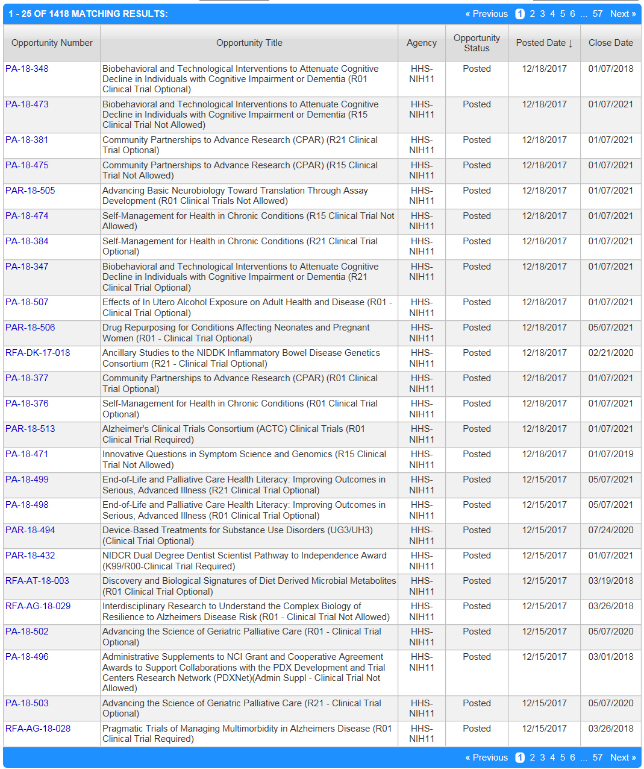
Other grant opportunities exist for rural communities. Unfortunately, each federal agency defines what a rural community is differently. For example, there are several fire department related grants for a rural community – provided they have 10,000 or fewer residents. The program description makes it clear that larger communities are not to apply.

The US Department of Agriculture may have one or more grant programs or technical assistance grants that could be of benefit to the City. Finance Department Staff is reviewing their grant catalog to determine what may be of use to the City.

Future Planning
The Finance Department Staff Manager has been compiling the necessary information to apply for several specific grants that have recently opened:

- Assistance to Firefighters Grant (also known as “AFG”). The application would be for financial assistance to replace our aging pumper truck, currently proposed for replacement in the FY19 budget year. The AFG typically opens for a six week period during the fiscal year and receives over $2B in grant applications each year. Unfortunately, the AFG program only has approximately $200M available each year to grant out to successful applications – meaning only 10% of the requested dollars are ever funded. The City had attempted to use this grant to replace our fire truck, but was instructed by the grant program staff that our request would not be eligible. The Fire Department is submitting a request under the AFG program for a SAFER grant. This program provides funding assistance to hire additional fire fighters. We are eligible for this grant. Success in obtaining the grant is dependent upon funding availability and the competition for the grant.

- Economic Development Assistance Grant – this is a grant offered by the US Department of Commerce and can be used for engineering/design of a public project, for actual construction costs (partial) of a public project, or both. The application would be for financial assistance to cover all eligible costs.

Finance Department Staff has also been gathering information regarding several additional grant topic areas:

- Public Safety Technical Assistance Grants – a specific grant has not been identified, but Finance Department Staff will prepare the necessary narratives and information to be used for a DOJ technical assistance grant for civilian staff to assist with GIS and database management for law enforcement.

- Risk Management Grant (POOL/PACT) – POOL/PACT has just recently made available a grant for cities to reduce risk. The program had been suspended for some time, and only made available in recent weeks. Finance Department Staff is working to identify an eligible risk management activity. One or more grant applications may then be submitted to POOL/PACT for consideration.

- Placemaking Grant (NEH. The program provides grants to assist communities to improve tourist visitation. The program requires a partnership with a local non-profit. Finance Department Staff has been working with the Chamber of Commerce to come up with potential ideas for a grant application to improve our tourist visitation numbers.

